Write a Python script to encrypt columnar transposition using keyword.

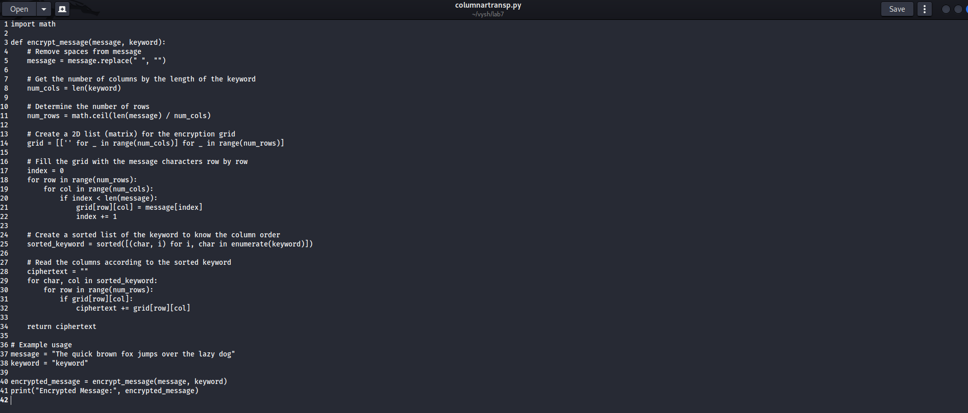

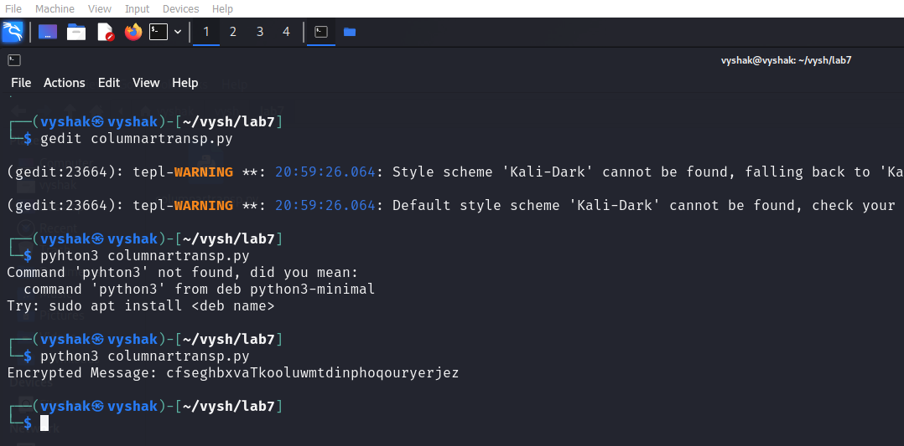

Write a Python script to encrypt double columnar transposition.

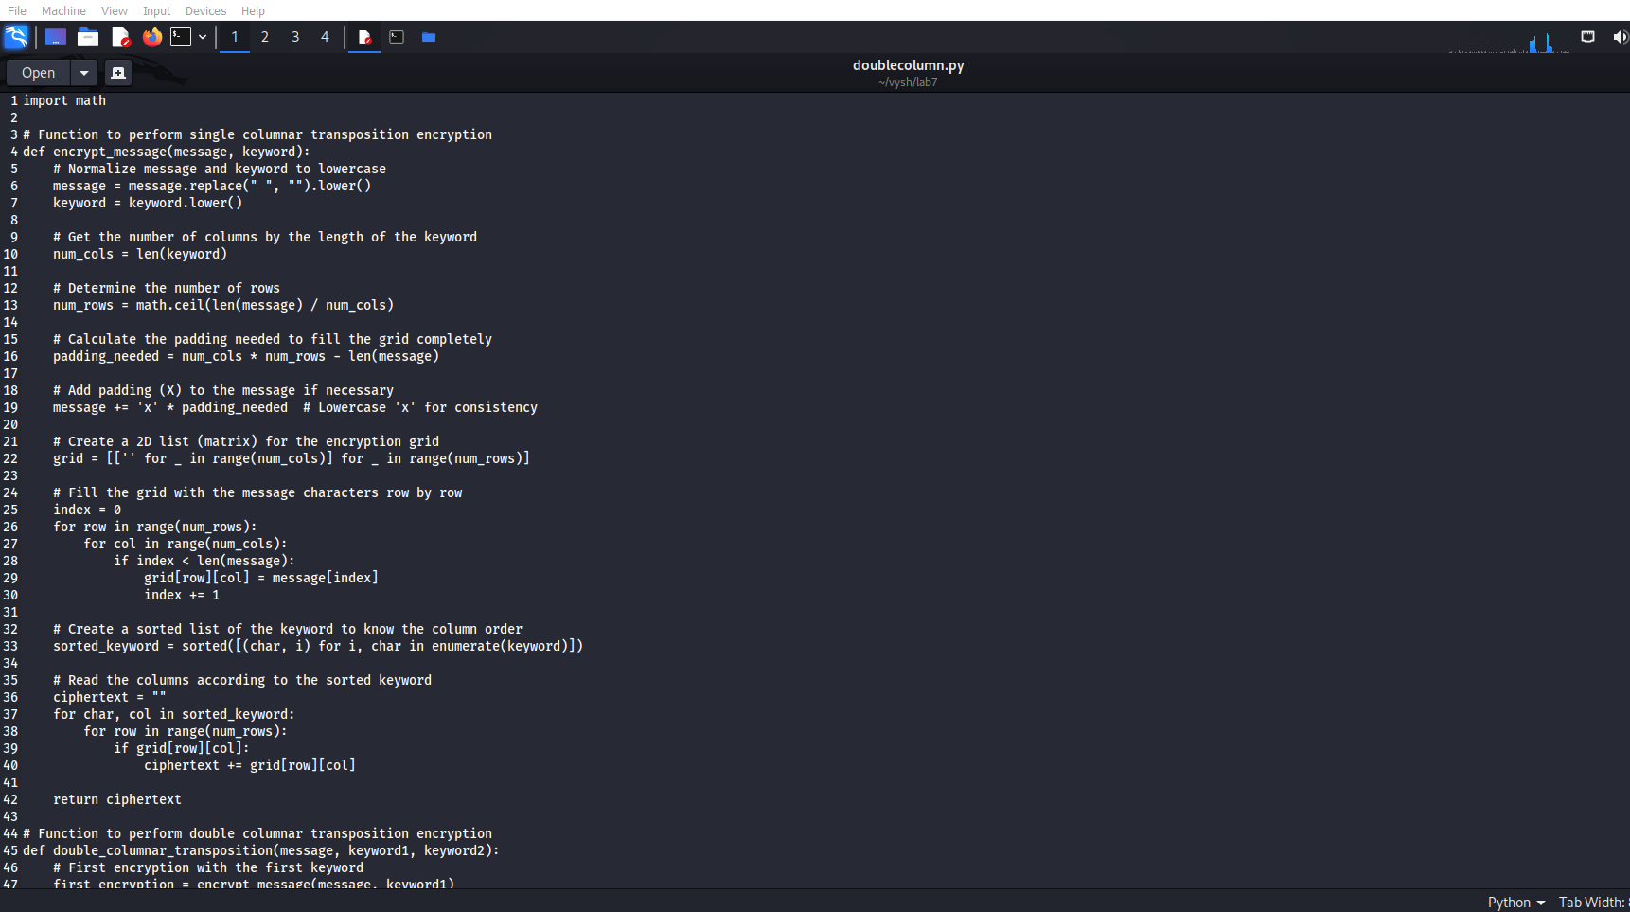

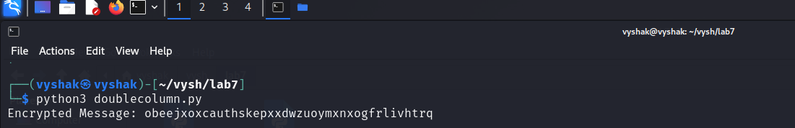

Write a Python script to encrypt the message “She is listening” using the 6-character keyword “PASCAL” with Vigenere cipher.

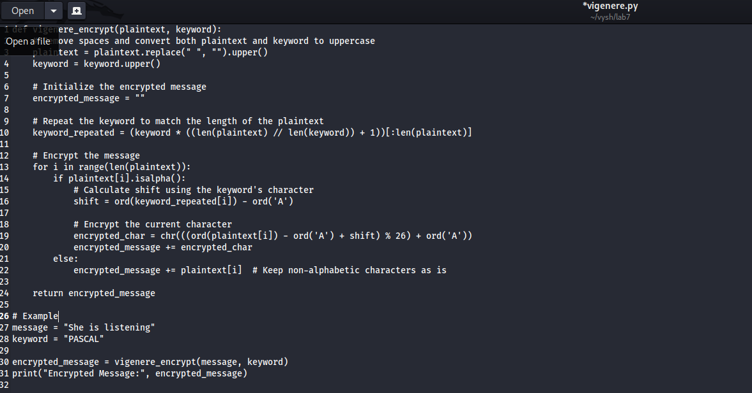

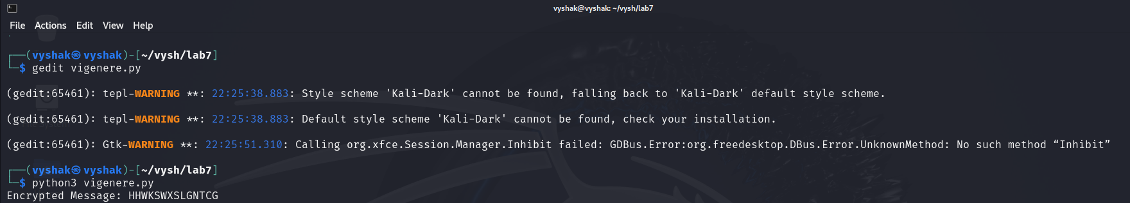

Write a Python script to encrypt and decrypt Hill cipher

